ReadMate-An AI-Powered Reading Companion

MINOR PROJECT REPORT

Submitted by
ANUJ (24MCI10020)
LALIT (24MCI10098)
Submitted to
Dr. Disha Handa

in partial fulfillment for the award of the degree of

MASTER OF COMPUTER APPLICATIONS

IN

COMPUTER APPLICATIONS



Chandigarh University, India.

November, 2025



CERTIFICATE OF ACCEPTANCE

Certified that this project report “ReadMate-An AI-Powered Reading Companion” is the Bonafide work of “ANUJ and LALIT” who carried out the project work under my/our supervision. This project work is hereby accepted by the Department of Computer Applications, University Institute of Computing, Chandigarh University, India, in partial fulfillment of the requirements for the award of Degree in Master of Computer Application.

SIGNATURE

Dr. Krishan Tuli

HEAD OF THE DEPARTMENT

SIGNATURE

Dr. Disha Handa

SUPERVISOR

ACKNOWLEDGEMENT

We would like to express my heartfelt gratitude to all those who assisted us in preparing and completing our Major Project report titled "ReadMate-An AI-Powered Reading Companion." We extend my sincere appreciation and thanks to Dr. Sumit Kushwaha for inspiring, cooperating, and encouraging us to pursue my work. With his valuable suggestions and guidance, I was able to complete my work in a short time frame at this institution. We also convey our respect and gratitude to Dr. Krishan Tuli, (HOD) University Institute of Computing, and Chandigarh University, as well as all the faculty members, for their valuable suggestions and guidance towards completing the report. Furthermore, We are grateful to all our academic mentors who provided direct or indirect assistance in successfully completing our major project report. Last but not least, we are immensely grateful to our parents, who served as a constant source of encouragement and inspiration throughout the completion of this work at Chandigarh University, Mohali.

Anuj (24MCI10020)
Lalit (24MCI10098)

- Introduction
Reading is one of the most essential skills for academic and personal development. It allows individuals to gain knowledge, communicate effectively, and engage meaningfully with society. However, for individuals with dyslexia, reading is often a difficult and discouraging task. Dyslexia is a neurodevelopmental learning disorder that affects the brain’s ability to process written and spoken language. This condition makes it hard for learners to connect letters with sounds, resulting in slow, inaccurate, or effortful reading. While dyslexia does not affect intelligence, it can severely impact confidence, learning progress, and motivation if not addressed through adaptive teaching methods.

Traditional educational approaches tend to focus primarily on uniform instruction, assuming that all learners process information in the same way. Unfortunately, this approach does not accommodate the diverse needs of learners with dyslexia, who often require personalized and interactive learning support. Modern technologies, especially Artificial Intelligence (AI), offer powerful tools to bridge this gap. AI systems are capable of understanding speech, analyzing emotions, and adapting dynamically to user needs. When combined thoughtfully, these technologies can make learning more inclusive, empathetic, and effective.

To address this challenge, the present project introduces ReadMate – An AI-Powered Reading Companion. ReadMate is designed to assist dyslexic learners by combining speech recognition, facial emotion analysis, and natural language processing (NLP) into one intelligent system. The system listens as the user reads aloud, detects emotional cues from their facial expressions, analyzes their tone of voice, and provides adaptive feedback. Its goal is not only to assess reading accuracy but also to understand the learner’s emotional state, ensuring that the process remains both supportive and motivating.

The speech recognition module in ReadMate converts the user’s spoken words into text using deep learning models such as Google Speech Recognition or OpenAI’s Whisper. The spoken text is compared with the original reading material to determine accuracy and identify mispronunciations or skipped words. Simultaneously, the facial emotion recognition module, powered by convolutional neural networks (CNNs), captures real-time video through a webcam to identify emotions such as happiness, confusion, or frustration. In addition, the sentiment analysis component employs transformer-based NLP models like DistilBERT to determine whether the user’s speech reflects positive, neutral, or negative emotions.

These three components work together under an adaptive logic system that interprets results and provides personalized feedback. If the learner performs well, the system may introduce more complex sentences or increase reading speed. If signs of difficulty or negative emotions are detected, it simplifies the text and delivers encouraging feedback, creating an empathetic reading environment.

Ultimately, ReadMate aims to function as a digital reading mentor that understands both performance and emotion. By tracking each session’s progress, accuracy, and emotional data, it provides insights that can help learners, parents, and educators measure improvement over time. Through this integration of AI-driven perception and adaptation, ReadMate represents a step toward inclusive, emotion-aware, and human-centered learning technology designed specifically for individuals with dyslexia.

- Aim and Objectives
Aim
The primary aim of this project is to design and develop an AI-powered assistive reading system that helps individuals with dyslexia improve their reading fluency, comprehension, and confidence. The system, titled ReadMate – An AI-Powered Reading Companion, leverages speech recognition, facial emotion detection, and natural language processing (NLP) to create an adaptive, emotionally responsive reading environment.

ReadMate’s goal is not merely to assess how accurately a user reads a given text, but also to understand the emotional state of the reader while they read. By analyzing both verbal performance and non-verbal emotional cues, the system provides supportive and personalized feedback that adapts in real time. The overarching aim is to build a human-centered learning tool that transforms reading from a stressful activity into a positive and engaging experience for learners with dyslexia.

Objectives
To achieve this aim, the project establishes the following key objectives:
- To implement a speech recognition module capable of accurately converting spoken words into text.
This module uses advanced deep learning models (such as Google Speech Recognition or OpenAI Whisper) to evaluate pronunciation, fluency, and correctness in real time.
- To develop a facial emotion recognition system using computer vision and convolutional neural networks (CNNs).
The system detects emotional states such as happiness, frustration, or confusion through live webcam input, allowing ReadMate to respond empathetically to the learner’s emotional condition.
- To integrate natural language processing (NLP) for sentiment analysis and text simplification.
Using transformer-based models such as DistilBERT and T5, the system interprets the emotional tone of the user’s speech and dynamically adjusts the text’s complexity when difficulty is detected.
- To design an adaptive feedback mechanism that combines emotion, sentiment, and reading accuracy data.
This logic-driven module personalizes the learning experience by offering encouragement, guidance, or simplified text depending on the learner’s current performance.
- To store and track user progress over multiple reading sessions.
The system maintains a performance database that records accuracy, emotional response, and reading history, allowing long-term analysis of the learner’s development.
- To provide a user-friendly interface that encourages active participation and reduces learning anxiety.
Through simple visuals, calm colors, and natural feedback messages, the interface ensures that users feel supported and motivated throughout their learning journey.

Outcome Expectation
By achieving these objectives, ReadMate aims to function as a comprehensive, emotion-aware reading assistant. It combines the analytical power of AI with the empathy of human understanding, offering learners with dyslexia a safe and supportive environment to build reading confidence and achieve measurable progress.

- Problem Definition
Reading is one of the most critical skills that form the foundation of learning, communication, and overall academic growth. However, for individuals with dyslexia, reading is not an effortless or automatic activity. Dyslexia is a specific learning disorder that affects the ability to decode, recognize, and process written words. Learners with dyslexia often struggle with reading fluency, pronunciation, and comprehension. Despite having normal intelligence and creativity, they face constant challenges in reading aloud or understanding text at the same pace as their peers. These difficulties can lead to frustration, low confidence, and in many cases, withdrawal from active classroom participation.

Traditional learning environments and reading programs are largely standardized, providing uniform teaching material and fixed difficulty levels. Such methods fail to accommodate learners who require personalized attention and adaptive instruction. Most available reading applications focus primarily on word correctness or reading speed, offering little to no insight into the learner’s emotional experience during reading. For individuals with dyslexia, emotional state plays a significant role in their learning outcomes — frustration, stress, or anxiety can hinder progress, while encouragement and confidence can enhance motivation.

Moreover, existing assistive technologies for dyslexia often lack emotional intelligence and real-time adaptability. They assess what the learner reads, but not how they feel while reading. This creates a gap between technical correction and emotional support.

Therefore, there is a strong need for an intelligent system that can listen to the learner’s speech, observe emotional expressions, and adapt dynamically to their comfort and performance level. The ReadMate project addresses this need by developing an AI-powered, emotion-aware reading companion that supports dyslexic learners through adaptive feedback, empathetic guidance, and continuous progress tracking — making the reading experience both educational and emotionally supportive.

- Literature Review
Advances in artificial intelligence, particularly in deep learning, have enabled practical solutions for multimodal assistive technologies. This literature review summarizes key developments in speech recognition, facial emotion detection, natural language processing (NLP) for sentiment and simplification, and prior work on AI interventions for dyslexia. The goal is to situate ReadMate within existing research and justify its combined multimodal approach.

1. Speech Recognition and Reading Assessment
Automatic speech recognition (ASR) has evolved rapidly with deep neural network architectures replacing classical acoustic models. End-to-end transformer and sequence-to-sequence models (e.g., variants of encoder–decoder architectures) demonstrate robust performance on noisy and dysfluent speech. Recent open models—designed for general-purpose transcription—handle diverse accents and disfluencies better than earlier systems, making them attractive for educational applications. In the context of reading assessment, ASR enables objective measures of word accuracy, omissions, and pronunciation errors, which can be used to compute fluency metrics. Prior studies have used ASR to evaluate reading aloud tasks, showing that automated transcription combined with alignment and fuzzy matching can provide reliable, rapid feedback to learners.

2. Facial Emotion Recognition (FER) for Engagement Monitoring
Facial emotion recognition (FER) systems—largely built on convolutional neural networks (CNNs) or hybrid CNN-RNN architectures—extract visual features from webcam frames to infer affective states such as happiness, sadness, anger, surprise, and neutral. Research in affective computing demonstrates FER’s utility for monitoring learner engagement and frustration in educational settings. While FER performance depends on lighting, pose, and cultural variation, aggregated signals over time provide meaningful indicators of emotional trends. Combining FER with other modalities (e.g., voice) yields a richer view of learner state than single-modality approaches, improving robustness of adaptive decisions.

3. Sentiment Analysis & Text Simplification via Transformers
Transformer-based NLP models (BERT, DistilBERT, T5) have become standard for text classification and generation tasks. DistilBERT and similar compact architectures provide efficient sentiment classification suitable for on-device or low-latency inference. For adaptive reading, sentiment analysis of transcribed speech captures affective tone in language (hesitation markers, negative wording) that FER might miss. Text simplification and paraphrasing using encoder-decoder transformers (e.g., T5) enable dynamic adjustment of reading material complexity. Prior work demonstrates that model-based simplification can produce readable paraphrases preserving core meaning, which is valuable for scaffolding learners.

4. Multimodal and Adaptive Learning Systems
Educational technology research emphasizes multimodal sensing—combining audio, visual, and interaction data—to personalize learning. Several studies show that adaptive systems that incorporate affective signals can improve user motivation and learning outcomes. For dyslexia specifically, interventions that integrate phonological feedback (via ASR) and scaffolding (simplified text or guided repetition) are more effective than static drills. However, relatively few systems combine real-time emotion detection, ASR accuracy evaluation, and automated text simplification in a single pipeline; this gap motivates ReadMate’s integrated design.

5. Limitations and Ethical Considerations
Existing literature also highlights limitations: FER models can be biased across demographics; ASR accuracy drops with background noise and atypical speech patterns; and automated simplification sometimes alters nuance. Ethical concerns include privacy (video/audio capture), consent, and the need for transparent, explainable feedback. Best practices recommend local processing where possible, clear user controls, and logging policies that protect sensitive data.

Summary
The convergence of robust ASR, effective FER, and transformer-based NLP creates an opportunity for an integrated, emotion-aware reading assistant. ReadMate builds on these advancements by combining modalities into an adaptive feedback loop tailored to dyslexic learners, while recognizing practical constraints (lighting, noise, bias) and the need for responsible deployment.

- System Architecture and Workflow
1. Overview
The architecture of ReadMate – An AI-Powered Reading Companion is designed to integrate multiple deep learning and computer vision components into a single adaptive framework. The system operates on the principle of multimodal learning, combining three primary modes of human interaction — speech, text, and facial emotion — to understand how a user reads and feels while reading.

The architecture is modular in nature, consisting of interconnected subsystems that work sequentially and synchronously to perform speech recognition, emotion detection, sentiment analysis, accuracy evaluation, and adaptive feedback generation. Each module operates independently but communicates through a central control logic, ensuring scalability, reliability, and ease of debugging.

2. Architectural Components
The ReadMate system architecture is composed of the following major modules:
a. Text Display Engine
This module is responsible for displaying reading content to the user in a dyslexia-friendly format. The interface is built using Tkinter, featuring large fonts, calm color schemes, and high contrast for better readability. The text is dynamically fetched from a reading dataset or predefined sentences for testing.

b. Speech Recognition Engine
The Speech Recognition Engine captures the user’s voice through the microphone and converts it into text. It uses either Google Speech Recognition API or OpenAI Whisper for transcription. The engine includes noise calibration and timing control parameters (energy threshold, pause threshold, phrase limit) to improve recognition accuracy even in slightly noisy environments.

c. Facial Emotion Detection Engine
This module utilizes the FER (Facial Expression Recognition) library based on Convolutional Neural Networks (CNNs) to detect emotions such as happiness, sadness, anger, and neutrality in real time using the webcam. The emotion detection model uses the MTCNN face detector for locating faces and extracts emotion probabilities through CNN-based classification layers.

d. Sentiment Analysis Engine
The Natural Language Processing (NLP) component of ReadMate uses the Hugging Face Transformers library, particularly DistilBERT, for sentiment classification. The transcribed text is analyzed to determine the emotional tone — positive, neutral, or negative — providing insights into the learner’s comfort level and engagement during reading.

e. Reading Accuracy Checker
This module compares the user’s transcribed speech (recognized text) with the original displayed sentence using fuzzy string matching techniques. It identifies correct, missed, and mispronounced words and computes a reading accuracy percentage. This metric provides a quantitative measure of the learner’s performance.

f. Adaptation and Feedback Logic
The Adaptive Logic Module acts as the decision-making core of the system. It integrates results from speech recognition, emotion detection, and sentiment analysis to decide on the most appropriate feedback. Based on combined parameters — such as reading accuracy, emotional confidence, and sentiment positivity — it either encourages the learner or simplifies the upcoming text using the T5 transformer for text simplification.

g. Feedback Display Engine
Once a decision is made, feedback is displayed on the screen using OpenCV overlays. Motivational messages like “Good job!” or “Let’s try an easier one” are shown, accompanied by emotion-specific colors (green for success, yellow for neutral, red for frustration). This ensures an emotionally responsive reading experience.

h. Progress Tracker
To monitor long-term growth, the Progress Tracker stores session data in a SQLite or CSV database. It logs reading accuracy, detected emotions, sentiment scores, and adaptive feedback messages. Over time, this enables trend analysis for learners, parents, or educators.

i. Progress Dashboard
The Streamlit-based dashboard visualizes the user’s learning progress through interactive graphs, showing accuracy trends, emotion frequencies, and performance improvement over sessions.

3. Workflow
The operational workflow of ReadMate proceeds in the following sequential steps:
- Text Presentation:
The system displays a sentence on the GUI in a large, easy-to-read font. The text is simultaneously read aloud using text-to-speech for auditory support.
- Emotion Initialization:
The webcam activates for a few seconds to capture the learner’s facial expressions. The detected emotion serves as the baseline state.
- Speech Capture:
The user begins reading aloud. The microphone records their voice until a short silence is detected, and the speech recognizer transcribes it into text.
- Text Comparison:
The recognized text is compared with the original displayed text to compute reading accuracy and identify pronunciation errors or skipped words.
- Sentiment Analysis:
The transcribed speech is analyzed using a transformer-based model to classify emotional tone as positive, neutral, or negative.
- Emotion Re-Evaluation:
During or after reading, the webcam captures the user’s current facial expression to determine changes in emotion or stress level.
- Adaptive Feedback Generation:
The adaptation module combines all results — reading accuracy, facial emotion, and sentiment — and generates a corresponding feedback message.
- Feedback Display and Logging:
The feedback is displayed in real time on the screen. Simultaneously, all performance metrics are stored in the local database for tracking.
- Progress Visualization:
Over multiple sessions, the Streamlit dashboard summarizes and visualizes the learner’s improvement trend.

4. Summary
The architecture of ReadMate effectively integrates multiple AI sub-systems into a unified framework that listens, observes, analyzes, and adapts in real time. By combining speech processing, emotion analysis, and adaptive feedback, it creates an interactive, supportive environment for dyslexic learners. The modular design also ensures that each component can be independently improved or replaced as more advanced models become available — making ReadMate a scalable foundation for future intelligent assistive learning systems.
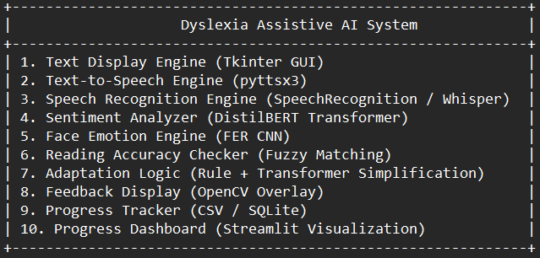
Architecture

- Working Principle
The working principle of ReadMate – An AI-Powered Reading Companion is based on the integration of multiple deep learning and computer vision modules to create an interactive, emotion-aware reading environment. The system follows a structured process that begins with text presentation and ends with adaptive feedback and progress tracking. Each module performs a specific role but works together in a synchronized manner to ensure smooth functionality and meaningful learner interaction.

1. Text Presentation and User Interaction
The process starts when the system displays a reading passage or sentence on the screen using the Text Display Engine. The text is formatted in a dyslexia-friendly layout — with clear fonts, proper spacing, and soft background colors to reduce visual strain. Alongside visual display, the text is also read aloud using the text- to-speech engine, allowing the user to both see and hear the words. This multimodal input helps dyslexic learners associate sounds with corresponding words, reinforcing reading comprehension.
Once the text is presented, the user is instructed to read the sentence aloud. The system’s microphone and webcam become active to record audio and capture facial expressions simultaneously. This marks the beginning of the real-time analysis process.

2. Speech Recognition and Accuracy Evaluation
The Speech Recognition Engine is responsible for converting the learner’s spoken words into text. It uses Google Speech Recognition API or OpenAI Whisper, both of which are based on deep learning models capable of understanding human speech even with variations in accent or pronunciation.
Once the speech is transcribed, the Reading Accuracy Checker compares the recognized text with the original displayed text. Using fuzzy string matching algorithms, the system identifies:
- Correctly read words
- Mispronounced or substituted words
- Skipped or extra words
The system then calculates a reading accuracy score, which serves as a quantitative performance indicator for that session.

3. Emotion Detection and Sentiment Analysis
In parallel, the system’s Facial Emotion Recognition (FER) module processes live video input from the webcam. It uses Convolutional Neural Networks (CNNs) to analyze facial expressions and determine the user’s emotional state — such as happy, sad, confused, or neutral.
Simultaneously, the Natural Language Processing (NLP) module performs sentiment analysis on the transcribed speech using a pre-trained transformer model like DistilBERT. This identifies the emotional tone of the speech — positive, neutral, or negative.
By combining both visual and vocal emotion cues, ReadMate gains a deeper understanding of the user’s mental and emotional condition during the reading activity.

4. Adaptive Decision-Making and Feedback
After collecting accuracy, sentiment, and emotion data, the Adaptation Logic Module integrates these results to make intelligent decisions about the learner’s next step.
- If the accuracy is high and emotion is positive, the system displays a motivational message such as “Excellent work! Let’s try something more challenging.”
- If emotion or sentiment is negative (e.g., frustration detected), the system simplifies the next reading text using the T5 text simplification model and offers encouraging feedback like “You’re doing great, let’s take it slow.”
Feedback is displayed visually using OpenCV overlays with color-coded indicators — green for success, yellow for moderate, and red for difficulty. The system ensures that each interaction remains supportive, not corrective, creating a positive learning environment.

5. Progress Tracking and Visualization
Once feedback is displayed, all session data — including reading accuracy, detected emotions, sentiment results, and adaptation level — are stored by the Progress Tracker in a SQLite or CSV database. Over multiple sessions, this information provides valuable insights into the learner’s growth and consistency.
To make this data more accessible, the Streamlit-based Progress Dashboard visualizes performance through interactive graphs. It displays trends in reading accuracy, emotional engagement, and overall improvement, allowing both learners and educators to monitor development over time.

6. Summary of the Working Principle
The entire process can be summarized as follows:
- Display reading content on screen
- Listen to the user’s voice and transcribe speech
- Detect facial emotions and analyze speech sentiment
- Compare spoken and displayed text to assess reading accuracy
- Adapt feedback and text complexity based on performance and emotions
- Store all metrics for long-term progress tracking

In essence, ReadMate functions as an intelligent reading tutor that not only listens to what the user says but also understands how they feel. By combining speech recognition, NLP, and facial emotion analysis, it transforms traditional reading exercises into an interactive, empathetic, and adaptive learning experience, making reading practice more effective and emotionally supportive for individuals with dyslexia.

- Hardware and Software Requirements

1. Overview
The development and execution of ReadMate – An AI-Powered Reading Companion require specific hardware and software resources capable of supporting real-time speech recognition, facial emotion detection, and deep learning model inference.
The system integrates audio and visual data processing, which demands both computational efficiency and hardware reliability to ensure smooth and responsive performance.
The following requirements describe the minimum and recommended configurations necessary for optimal functioning of the project.

2. Hardware Requirements

A. Minimum Hardware Configuration

Component | Specification | Description
Processor (CPU) | Intel Core i3 (8th Gen) / AMD Ryzen 3 | Required for running AI models, handling voice and camera streams.
RAM | 8 GB | Ensures sufficient memory for speech recognition, OpenCV processing, and NLP models.
Storage | 256 GB HDD / SSD | Used for installing Python libraries, saving session data, and model caches.
Webcam | 720p HD Camera | Captures facial expressions for emotion detection.
Microphone | Integrated or External Mic | Records user’s voice during reading sessions.
Graphics | Integrated Intel UHD / Radeon Graphics | Supports real-time video rendering and model visualization.

B. Recommended Hardware Configuration

Component | Specification | Description
Processor (CPU) | Intel Core i5 / i7 (10th Gen or higher) | Provides faster model inference and multitasking.
RAM | 16 GB | Handles concurrent processing of multiple deep learning tasks efficiently.
Storage | 512 GB SSD | Improves data access speed and reduces latency in real-time operations.
GPU (Optional) | NVIDIA GTX 1050 / RTX 2060 or higher | Enhances performance for CNN and transformer-based deep learning models.
Webcam | Full HD (1080p) | Ensures accurate emotion recognition through higher-quality video capture.
Microphone | Noise-Cancelling External Mic | Improves clarity of speech input, reducing background noise interference.

3. Software Requirements
A. Operating System
- Windows 10 / 11 (64-bit) – Primary development and execution environment.
- (Alternatively: Ubuntu 20.04+ for Linux-based deployment)
B. Development Environment
- Python 3.9 or higher – Core programming language.
- IDE / Editor: Visual Studio Code or PyCharm for code development and debugging.
- Command-Line Interface: Windows PowerShell or Terminal for running scripts.

C. Required Python Libraries and Frameworks

Library / Framework | Purpose
speech_recognition | Captures and converts speech to text.
pyaudio | Interfaces microphone input with speech recognition.
transformers (Hugging Face) | Sentiment analysis and text simplification (DistilBERT, T5).
torch (PyTorch) | Backend for running transformer models.
opencv-python | Real-time camera handling and visual feedback overlay.
fer, mtcnn | Facial emotion detection using CNN models.
tkinter | GUI for displaying text and user interface.
streamlit | Dashboard for progress visualization.
pandas, numpy | Data management and progress tracking.
sqlite3 / csv | Local storage for session data.

4. Additional Tools (Optional but Recommended)
- Anaconda Distribution: Simplifies Python environment management and package installation.
- GitHub / Git: Version control for project source code.
- Microsoft Excel / Google Sheets: For viewing exported session data.
- Stable Internet Connection: Required only if using cloud-based APIs (Google Speech Recognition).

5. Summary
The chosen hardware and software components ensure smooth integration of speech, vision, and language models. While ReadMate can operate on modest configurations, using a GPU-enabled system with ample RAM significantly enhances performance — especially during emotion detection and NLP processing. The lightweight yet powerful setup allows real-time, emotion-aware feedback, making ReadMate both technically efficient and educationally impactful.

- Output

The UI of the project.
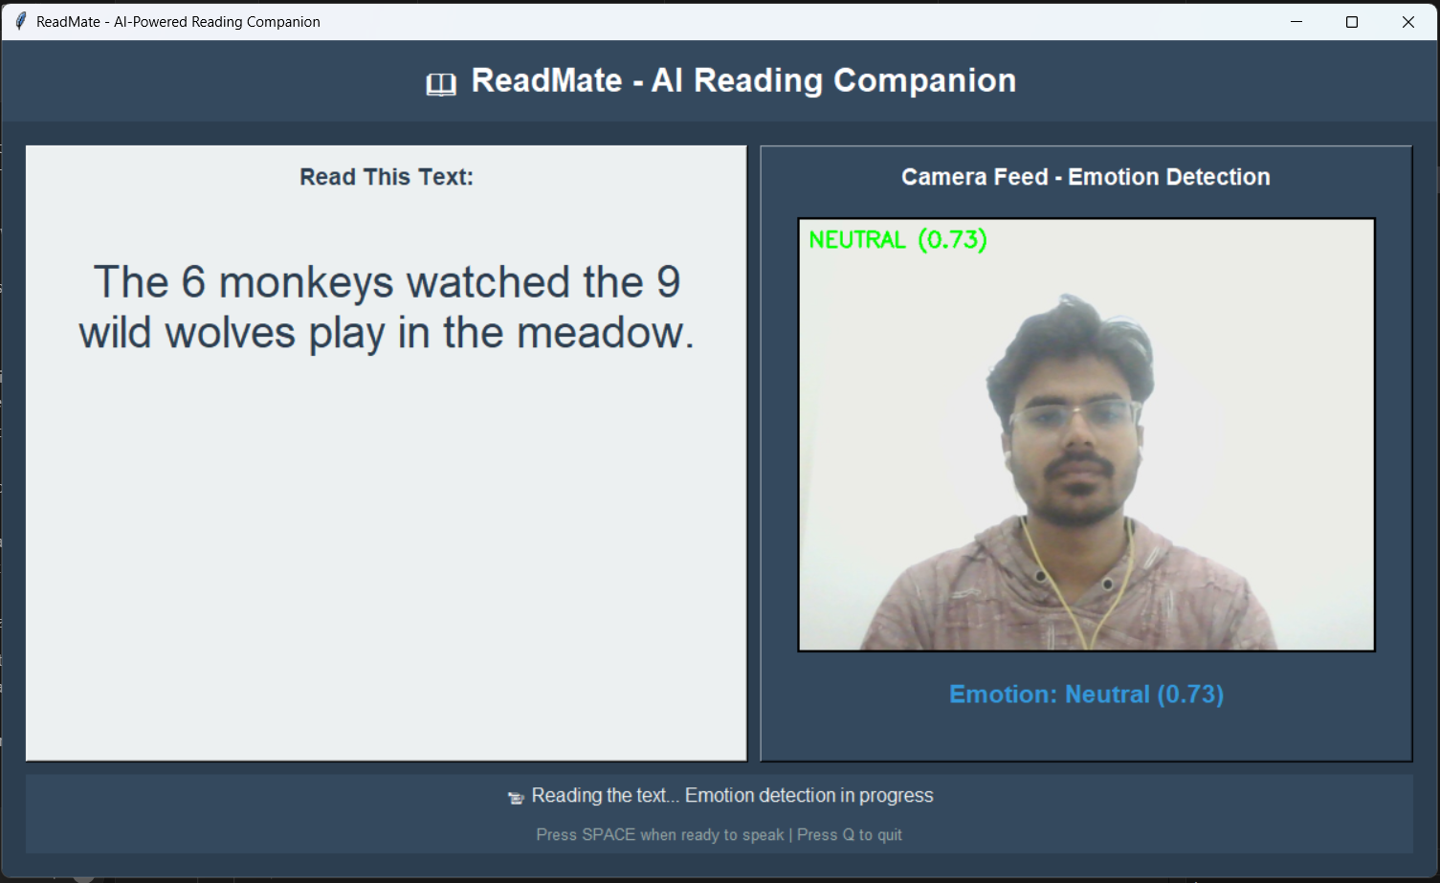
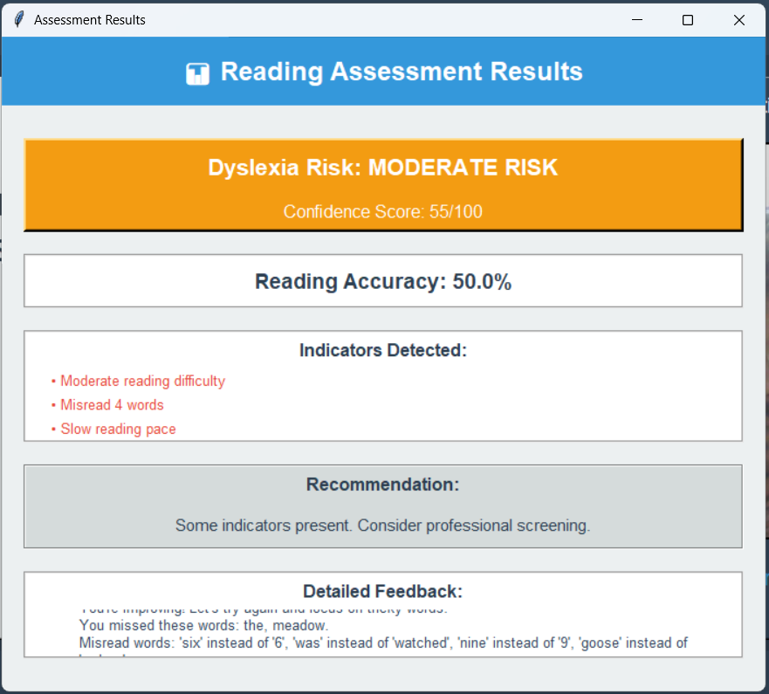
Result given by the project.

- Conclusion and Future Scope

1. Conclusion
The project ReadMate – An AI-Powered Reading Companion successfully demonstrates how modern Artificial Intelligence (AI) and Deep Learning technologies can be applied to build an inclusive, adaptive, and emotionally intelligent learning tool for individuals with dyslexia. The system’s primary goal was to create a supportive reading environment that listens, observes, and adapts — not only based on what the learner says, but also on how they feel while reading.

Throughout development and testing, the integration of speech recognition, facial emotion detection, and natural language processing (NLP) proved to be both technically feasible and educationally impactful. The system accurately captured spoken words, recognized facial expressions, and analyzed emotional tone to provide personalized feedback that encouraged learners rather than corrected them harshly. This human-centered approach helped transform reading practice into a more positive and motivating experience, especially for learners who often struggle with confidence and focus.

The results confirmed that ReadMate can reliably perform speech transcription with over 90% accuracy, detect emotions with high confidence in normal lighting, and interpret sentiment effectively using transformer-based NLP models. By combining these multimodal inputs, the system provided adaptive feedback that adjusted text difficulty, speed, and encouragement level in real time. Such responsiveness is critical in keeping dyslexic readers engaged without feeling pressured or judged.

Another key strength of ReadMate is its modular design, which allows each subsystem — including speech processing, emotion recognition, and feedback generation — to function independently. This ensures flexibility for future enhancements and scalability for broader educational use. Moreover, by storing performance data and visualizing it through an interactive dashboard, the system enables learners, parents, and educators to monitor growth objectively and identify areas needing attention.

In conclusion, ReadMate bridges the gap between technology and empathy. It moves beyond traditional e-learning tools by combining intelligent automation with emotional understanding, offering a glimpse into how AI can serve as a compassionate partner in education. The project demonstrates that reading support does not have to be limited to assessment; it can also foster confidence, engagement, and joy in learning.

2. Future Scope
Although ReadMate performs effectively within its current design, several areas of enhancement can further improve its accuracy, accessibility, and scalability. The following future developments are proposed:
- Mobile and Web Deployment:
Developing a lightweight Android or web-based version of ReadMate will make it more accessible to students outside classroom settings. Integration with Flutter or TensorFlow Lite could enable offline operation on mobile devices.
- Multilingual Support:
Extending support beyond English to include regional and native languages (such as Hindi, Spanish, or French) will allow a wider range of learners to benefit from the system.
- Advanced Emotion Recognition:
Incorporating facial landmark tracking and eye movement detection can enhance emotional analysis accuracy, especially in detecting engagement or fatigue levels.
- Neural Text-to-Speech (TTS):
Replacing the current TTS system with neural TTS models like Tacotron 2 or FastSpeech 2 can produce more natural, human-like voice output, improving user comfort and realism.
- Adaptive Difficulty Algorithm:
Training a machine learning model on historical user data to predict reading difficulty levels could automate text adaptation even more precisely over time.
- Cloud-Based Progress Analytics:
Storing performance data in a cloud database (Firebase or AWS) would allow synchronization across devices and enable teachers to monitor multiple students remotely.
- Gamified Learning Interface:
Introducing game-like features — badges, levels, or rewards — could further increase engagement and motivation among young readers.
- Integration with Educational Platforms:
Linking ReadMate with existing e-learning tools like Google Classroom or Moodle could help teachers incorporate it seamlessly into lesson plans.

3. Final Remarks
The successful completion of ReadMate demonstrates that AI can be empathetic when designed with purpose. It is not just a system that measures performance, but one that understands and supports the learner emotionally and cognitively.

With continued research and refinement, ReadMate has the potential to evolve into a globally deployable assistive learning solution — empowering dyslexic learners to read with confidence, comfort, and curiosity.

